Rossmoor Photography Club BULLETIN
July 2026

Vicky Richardson and Bruce Lescher co-presidents
vickyarichardson@aol.com or brucelescher@comcast.net or you can reach us at club website.
- January-February: Vicky May-June: Vicky
- March-April: Bruce July-August: Bruce
July Calendar
- Two club meetings: July 1 and 15, 6:30 PM
- Board Meeting: July 9, 9:30 AM, Mulligan Room
- Movie Night: July 14, 7PM, Peacock Hall
- MeetUp: Tuesday, June 30, See information below.
- Webinar Photography Education Series: Monday June 29, information below.

- Creekside Gallery: Visit Black and White Exhibit with friends and neighbors

- Redwood Room: Visit Beautiful Exhibit with friends and neighbors

- Fireside Gallery: Ojars Kratins’ Retrospective, Visit with friends and neighbors

- Event Center: Visit Beautiful Exhibit with friends and neighbors

July COMPETITION SCHEDULE
First Wednesday, July 1st
Monday, June 29th, Noon deadline to enter images
Digital: Pictorial Alternate:
Prints: Pictorial, Monochrome Alternate: Spider Webs

Third Wednesday, July 15th
Monday, July14th, Noon deadline to enter images.
Digital: Travel & Nature
Prints: Creative & Journalism

View Future Competitions visit our website.

MeetUp
July 30th 9:30 AM MeetUp, "Walnut Creek Downtown Walls – North of Olympic".
We will wander around a three to four block area looking for interesting shapes, patterns, colors, messages, reflections, manhole covers, insects, etc. Meet: Gateway Parking Lot at 9:30 AM.
Share possible MeetUp locations: vickyarichardson@aol.com

New Members/ Current Members Orientation
Just send Vicky an email vickyarichardson@aol.com if you have questions about how to enter images into competitions, how to navigate our web site, or how to prepare your images for hanging in our galleries. Appointments are in the Redwood Room, 10:30 AM Tuesday, Thursday and/or Friday.

Education
Movie Night
July 14th Movie Night: “Don’t Blink” 7PM, Peacock Hall
Photographer: Robert Frank
Another must see! Thank you, Sean!

Webinar Photography Education Series: Monday June 29
From Zina Mirsky Link: Using AI Prompts for nature photography
Here is a free webinar offered this coming Monday morning (see below) from a photographer who gave a presentation for N4C last year. (Russell A. Graves)
Some of you might be interested in this unusual, but timely topic. Join if you wish! ..../zina
PS Note that the time is 12 Noon Central, which is 10 AM Pacific time.
This month's webinar is a good one. We're going to be digging in on how using AI prompts with sites like Chat GPT or Google Gemini can actually help improve your nature photography.

N4C Portfolio Competition Zina Mirsky sent an email with all of the information needed to participate.
If you are interested, start by reading the official rules. Go to https://N4C.org, hover over “Competitions” and click on “Portfolio Competition Rules”. The best place to learn about Portfolios is on the N4C YouTube channel: https://YouTube.com/@NorthernCaliforniaCameraClubs. Click on “Playlists” and under “Portfolio Competition” click “View full playlist”.
How to develop your portfolio
N4C Portfolihttps://www.youtube.com/watch?v=OHK3tmlwpmY.

Membership Chairperson for August through November

Bruce Lescher and Vicky Richardson will be sharing in setting up judges for our competitions through the end of the year. We will be happy to share information with you as we progress through the next few months if you are considering this position when you give a hand managing our club.

Thank you
Print Competition Coordinators: Bruce Lescher, Bob Adler and Ron Douglas and Projection: Zina Mirsky, Dick Bogaert, Marsha Kirschbaum, and Richard Frank we appreciate your time managing projection for our competitions and thank you Zina, for all of your time and effort coordinating N4C activities.
A special thanks to Ron Douglas and Cheryl Stanley for managing our last club meeting in June. Bruce and I appreciate your time and effort while we were both engaged in family activities.

Local Galleries/Competitions – View Fabulous Photography!
Alameda County Fair, June 19 – July 12, Pleasanton. Great Photography
Blackhawk Gallery, Danville: Open to the public Wed, Th, & Sun: 12 - 5PM, Fri & Sat: 11-8PM,
Closed Mon & Tues
2026 Gallery MeetUP? Are you interested in meeting at any one of the great galleries available in Contra Costa County? Let me (Vicky) know.
Photography Opportunities!
Photography Exhibits in Contra Costa County
Arts Contra Costa County (ARTSCCC) hosts the quarterly Art Passages photography exhibition at the County Administration Building in Martinez, featuring local and regional photographers from across the county.

A few of our judges’ favorite reminders:
- Pay attention to the edges of your entry. Unwanted people, items, spots, head, foot, etc,?
- Look at the quality of the entry: right size, no pixelation, sharp focus?
- Are the feet of the people or animals cut off?
- Are buildings or subject photographed from one side or the other – prefer not straight on?
- Is your subject matter in a power point – not dead center?
- Is your subject obvious?
- “Busy” means extra things going on in the background, foreground or either side. Keep it simple– “Less is more”.
- Black & White Photo: Is it a true black and true white in the photograph? No tints - tones
- Nature – No “hand of man” unless the subject is in its true environment.
- Nature and Journalism caption: Who, What, When, Where & Why?
- Are buildings perpendicular to the photo edge?
- Did you remember not to give nature subjects human attributes?
- Do not include your cataloging process in the title of the work.
- Hot spots are popular with judges. They love to point out why your work is below standard because of Hot Spots. Super bright white – sometimes glare from reflections.
- White is ok unless it distracts the viewer from the main subject of the photograph.
“the eye goes first to the whitest/brightest area in the work.”
- Creative Competition means presenting your creative work, not any other artist’s creative work. Requirements: a subject, image or images that are transformed by your efforts into an interesting, new, or surprising vantage point/color palette which gives the viewer a fresh new or surprising perspective.
- Remember, most judges look for an immediate impact of an image.
Send me your favorite Judges’ remarks.

Redwood Room Exhibit
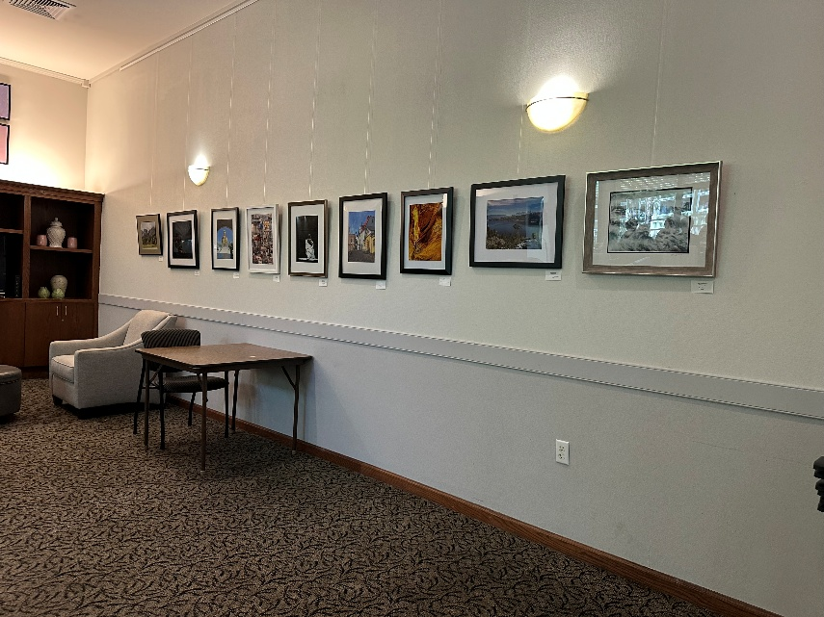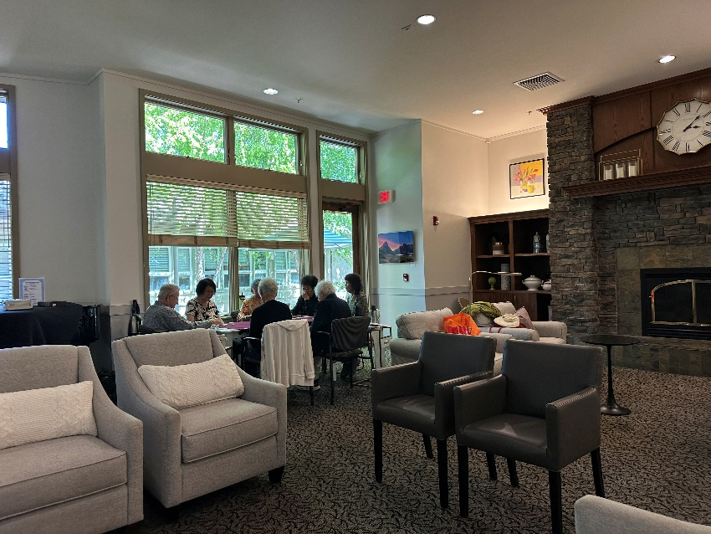
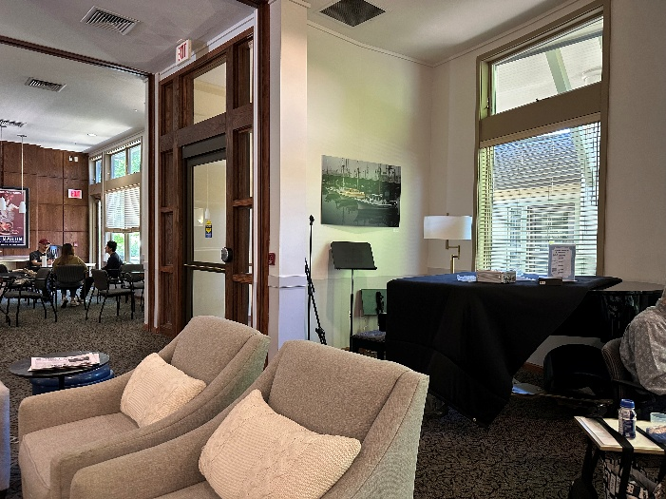

Club Fair. June 4
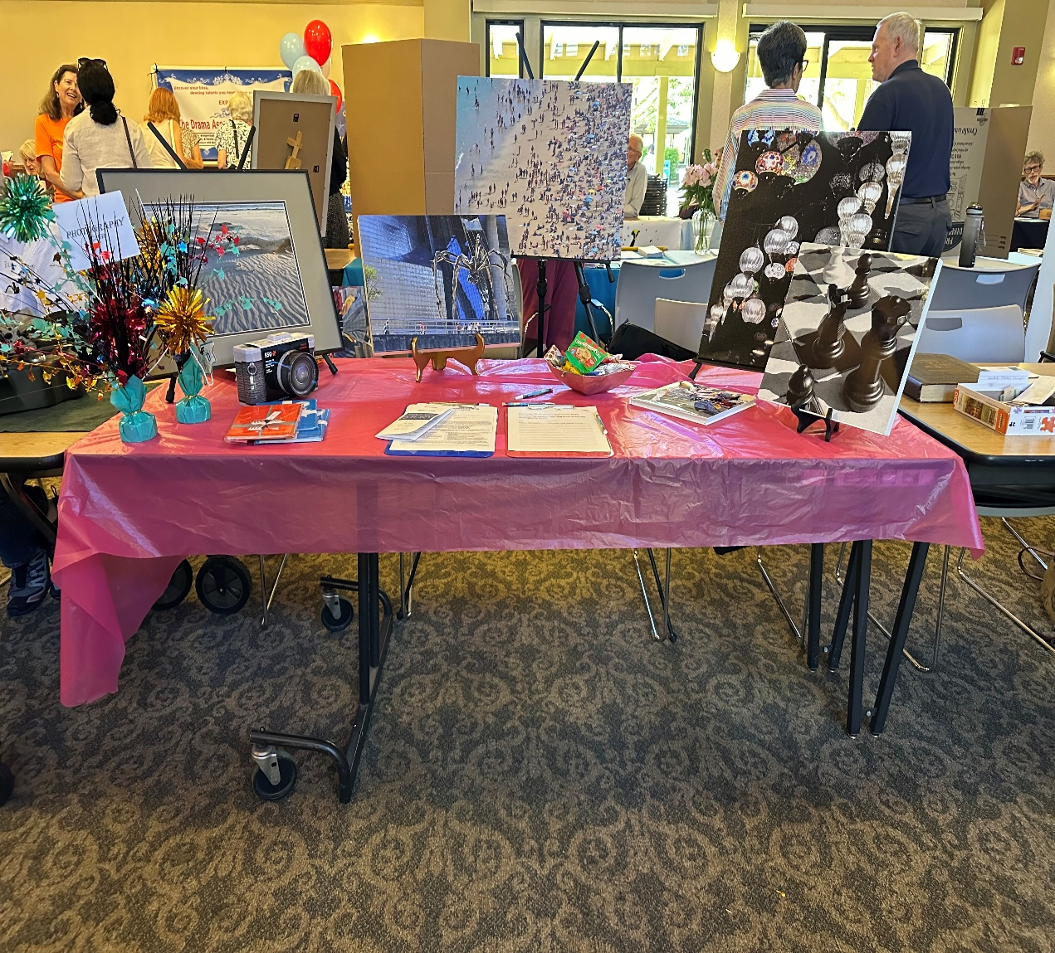

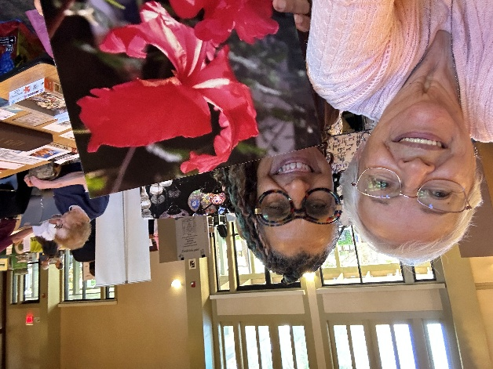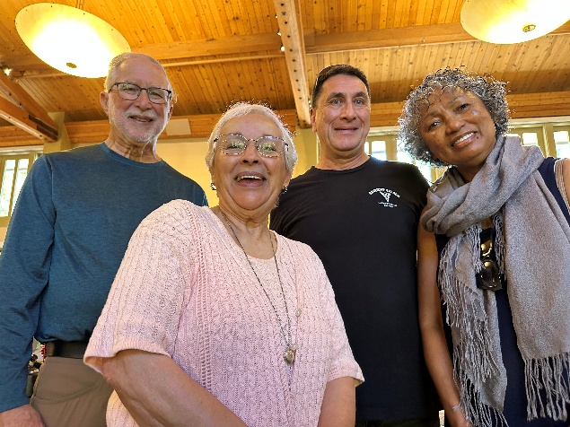

Fireside Gallery Ojars Kratins Retrospective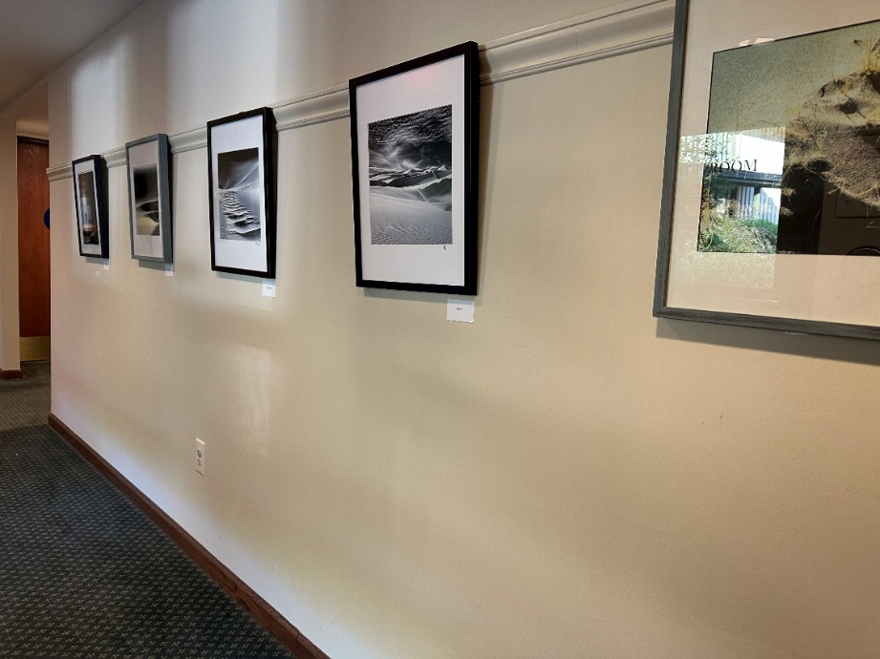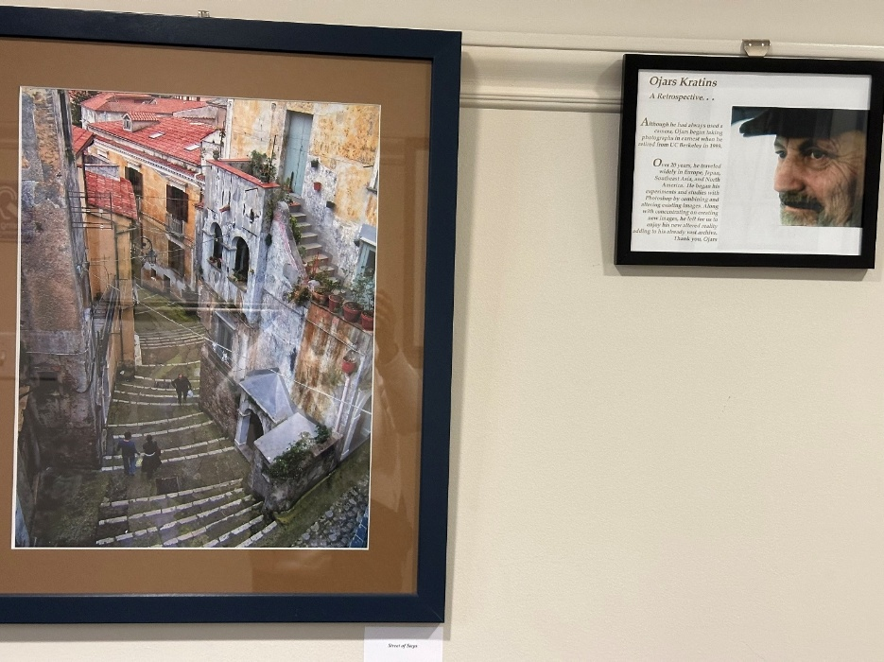

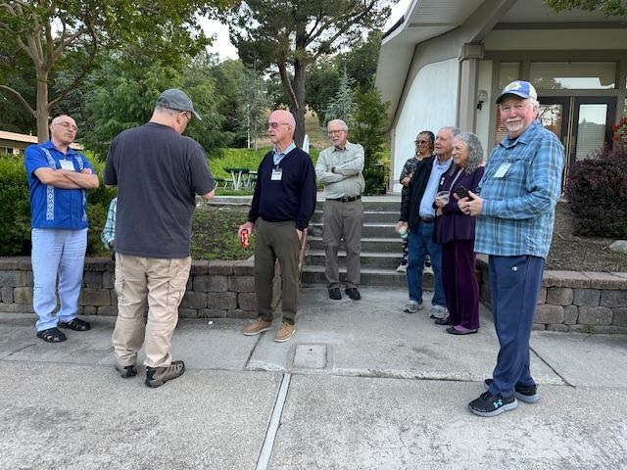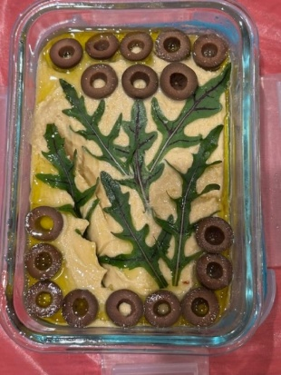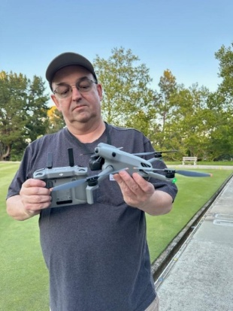
April 5th Wednesday with Sean’s Drones! Betty Rothaus’ beautiful appetizer!

April MeetUp – down town Walnut Creek

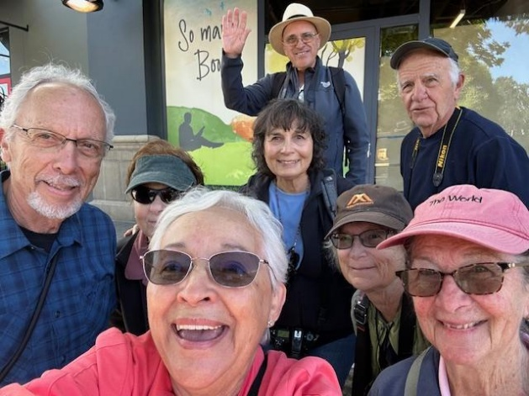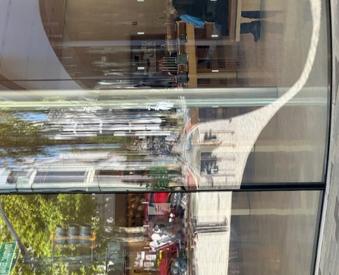
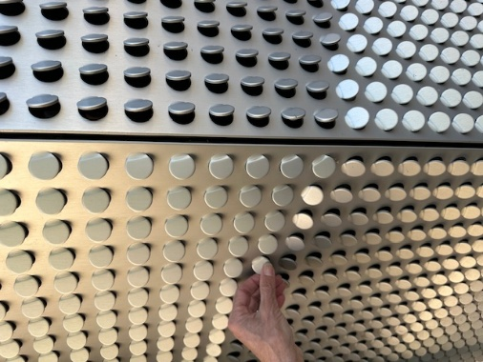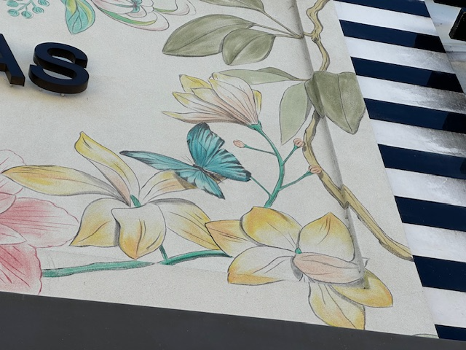

March MeetUp Ron, Wendy, Zina, Charlotte, Vicky
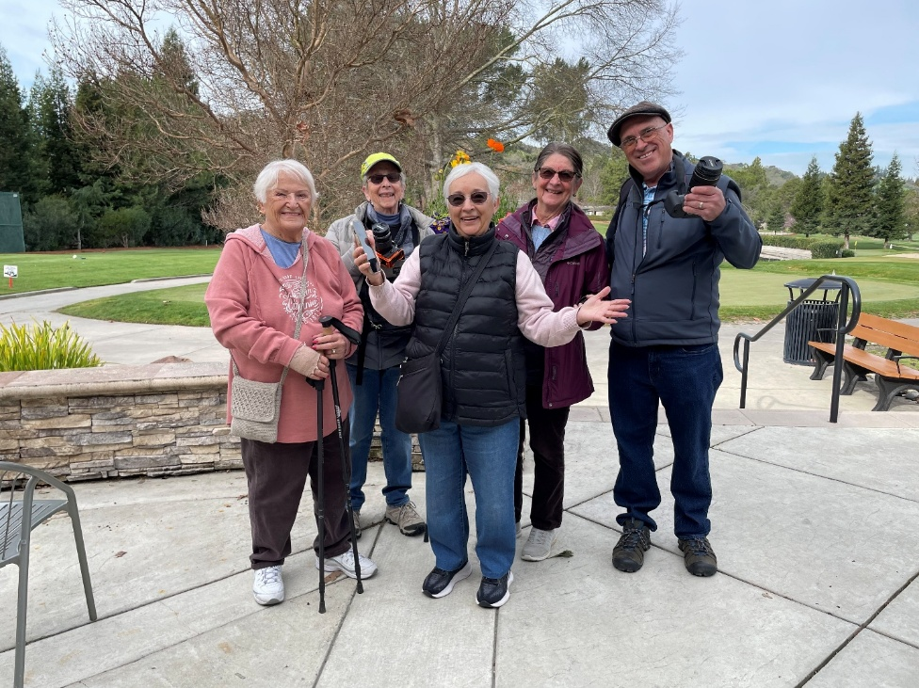

Photography Club Management – “It takes a village”. . . .
- Board Members (4) Co Presidents, Vicky Richardson & Bruce Lescher,
Vice President, Sean McDonough, Treasurer, Richard Frank, and Secretary Zina Mirsky.
- Membership (1) Keeps track of our membership, sends welcome letter to new members, makes and sets out name tags and signup sheet for meetings. Cheryl Stanley
- Webmaster (1) manages our website: communicates with website firm, makes changes as needed, keeps information up to date, helps new members find their way around the site. Sean McDonough
- Judges (1) uses list of N4C approved judges to schedule for Wednesday night meetings. Leonard James, through July.
- Competition Night Prints Crew (3) sets up and manages the prints for judging. Bruce Lescher, Bob Adler, Ron Douglas
- Competition Projection Crew (3) alternate the position between them to man the club computer for Wednesday night competitions, sends competition information to Webmaster, Rossmoor News. Zina Mirsky, Dick Bogaert, Richard Frank
- Hospitality (1) shops for and sets up the snacks and beverages for Wednesday night meetings and two Fifth Wednesdays per year. Vicky Richardson, Ron Douglas
- N4C Management Group (3) Shuttle the winning prints to and from N4C, attends one N4C meeting a month (evening), communicates to our club members notices from N4C, Zina Mirsky, Don Columbana
- Publicity (1) Sends information about our competitions and activities to Rossmoor News. Zina Mirsky
- Movie Night Coordinator (1) Finds interesting photography films, makes flyer to advertise film in Rossmoor News, our website, and Wednesday night meetings. Sean McDonough
- Nominating Committee (4) Step One: August 27 committee is formed. Step Two: Canvassing of current board members and committee heads to determine who will continue for following year. Step Three: When that list is completed, canvass general membership fills positions that will be open. Step Four: Report to board for approval of the following year’s slate. Step Five: Present slate to Annual General Meeting in November for a vote on the 2027 slate.
- Orientation (1) Meets at Redwood Room, Gateway for 45 minutes to demonstrate use of club’s website, answers questions about club, and an instant friend for new members. Vicky Richardson
- Gallery Management Creekside: Bruce Lescher, Vicky Richardson, Fireside, Vicky Richardson, Bob Adler, Event Center: Zina Mirsky, Bob Adler, Redwood Room, Valery Garrette

Please send me your ideas to add to our future Bulletins. vickyarichardson@aol.comThank you.

